LOUISIANA BOARD OF PROFESSIONAL GEOSCIENTISTS
9643 Brookline Ave., Ste. 101, Baton Rouge, Louisiana 70809
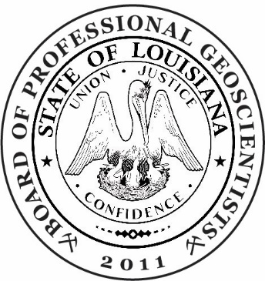

OUTREACH COMMITTEE MEETING
Wednesday, July 10, 2024
Virtual Meeting on Zoom

AGENDA

- Opening comments
- Thanks to Bill Finley
- Outreach with strategic focus
- Examples of other states/organizations: TX, NY, Indiana, Oregon, Washington,
- Outreach to Universities regarding potential Engineering Geology track
- Suggestions for future
- Adjourn

Committee members: D. Culpepper (Chair), W. Finley, D. Williamson, E. McDade

